Lesson 8 : Area and volume (B)

Checkpoint 2
Checkpoint 1

Surface Area of Sphere
Volume of Sphere

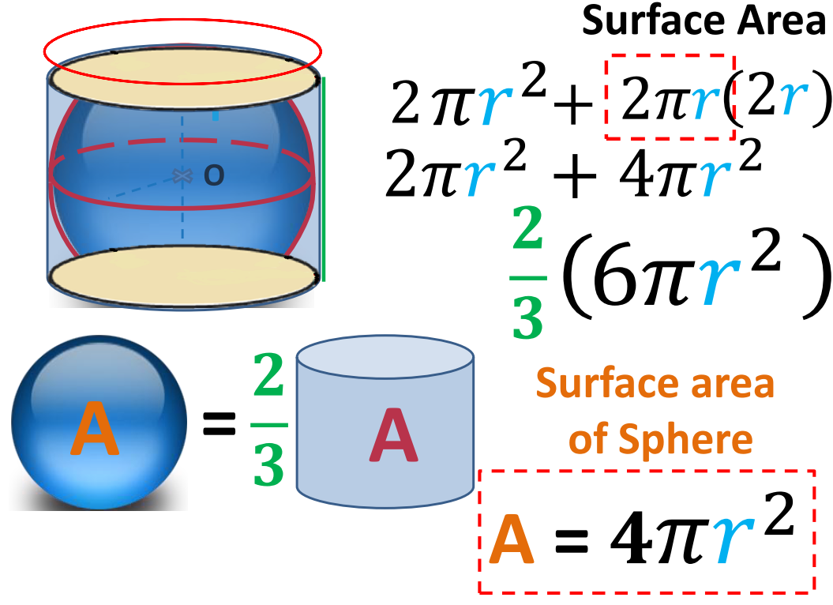
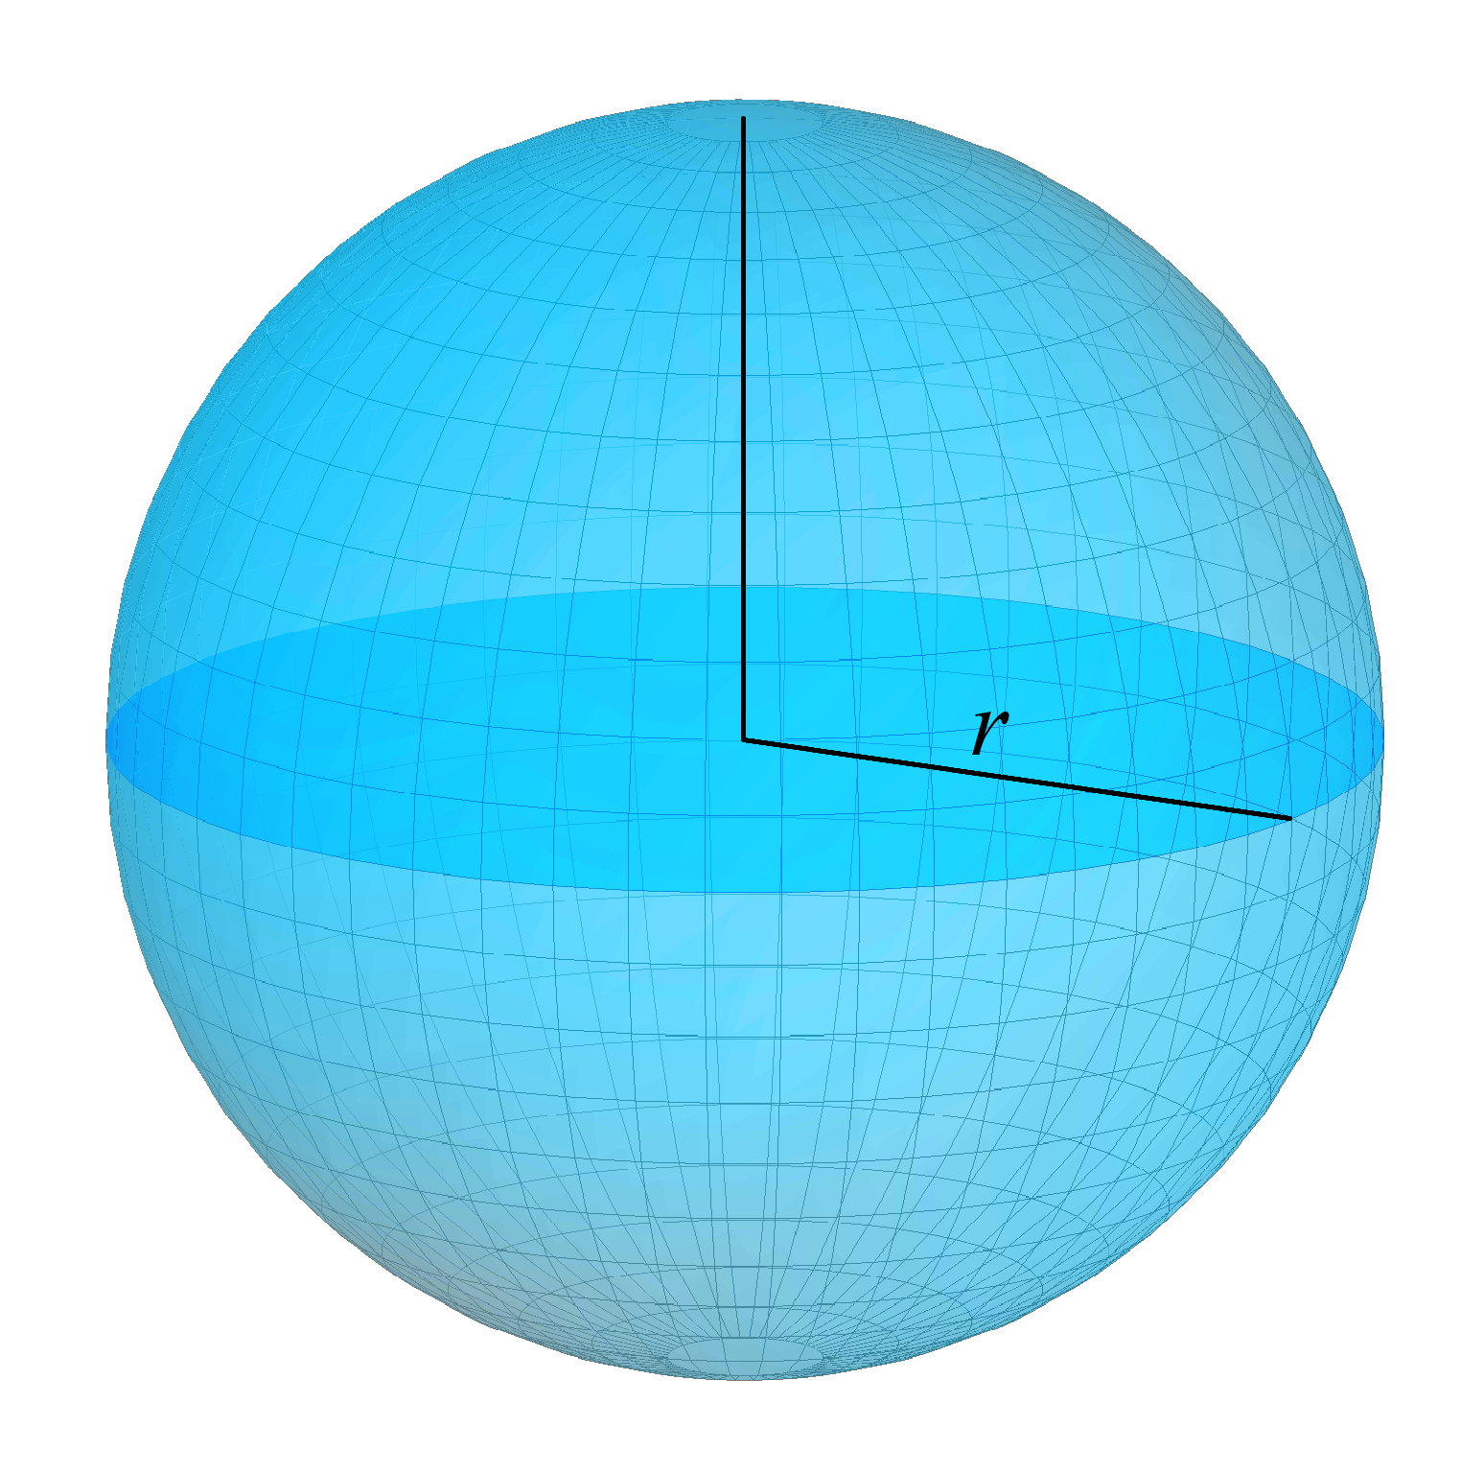
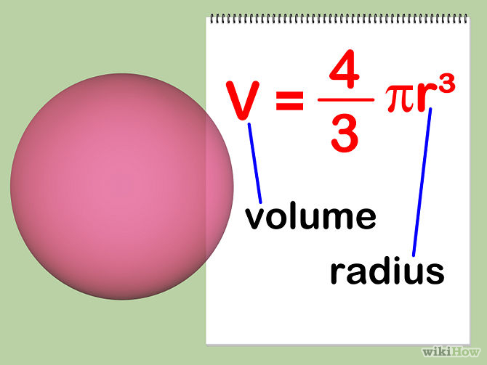
Surface area

For each sphere or hemisphere in Q1−3, find the
(a) volume, (b) total surface area. (Give the answers in terms of π.)
1. 2. 3.

18 mm
3 m
6 cm

Find the unknown in each of the following spheres or hemispheres in Q4−6.
4. 5. 6

r m
volume =
r cm
total surface area = 12π cm²
r cm
surface area = 100π cm²

7. The surface area of a spherical basketball is 1 850 cm². Find
(a) its radius,
(b) its volume.
(Give the answers correct to 3 significant figures.)

8. The figure shows a hemisphere. The area of its base is 900π mm². Find its volume in terms of π.

9. The diameter of a spherical Christmas ball is 7 cm. Find the surface area of the ball in terms of π.

10. The curved surface area of a hemisphere is 200 m². Find the circumference of its base, correct to 3 significant figures.

11. A large solid metal sphere of radius 15 cm is melted and recast into 27 identical small solid metal spheres. Find
(a) the radius of each small sphere,
(b) the surface area of each small sphere in terms of π.

12. The volumes of the sphere and the cylinder in the figure are the same. Find the base radius of the cylinder.
9 cm
6.75 cm

13. The figure shows a steel bowl in the shape of a hemisphere. The bowl is 0.2 cm thick with an internal diameter of 15.6 cm. If there is 600 cm³ of steel, at most how many bowls can be made?

0.2 cm
15.6 cm

14. In the figure, there is some water in a cylindrical container of base radius 4.8 cm. An iron sphere of diameter 7.2 cm is immersed in water. Then, the depth of water rises to 13 cm. Find the original depth of water.

13 cm
4.8 cm

15. In the figure, a vessel consists of a hemisphere and a cylinder with a common base. The base diameter of the hemisphere is 30 cm. The capacity of the vessel is 9 000π cm³. Is the height of the vessel less than 40 cm? Explain your answer.

16. The solid in the figure is formed by two hemispheres. The radius of the smaller hemisphere is 4 cm. The curved surface area of the larger hemisphere is 40.5π cm². Find the total surface area of the solid, correct to the nearest cm².
4 cm

17. The solid in the figure is formed by a right cylinder and a hemisphere. The base diameter and the height of the cylinder are 20 cm and 15 cm respectively. The base diameter of the hemisphere is 12 cm. Find
(a) the curved surface area of the cylinder,
(b) the curved surface area of the hemisphere,
(c) the total surface area of the solid.
(Give the answers in terms of π.)

15 cm
20 cm
12 cm

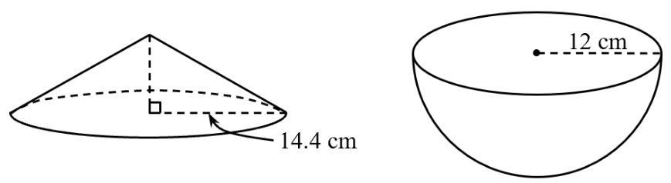

18. The figure shows a right circular cone of base radius 14.4 cm and a hemisphere of radius
12 cm. Their total surface areas are the same.
(a) Find the slant height of the cone.
(b) Is the volume of the hemisphere greater than that of the cone? Explain your answer.

19. The figure shows a sausage, which is in the shape of a right cylinder with two hemispheres at both ends. The diameter of each hemisphere is 1.5 cm. The total surface area of the sausage is 20.25π cm².
(a) Find the length of the whole sausage.
(b) Find the volume of the whole sausage in terms of π.

1.5 cm

20. The solid in the figure consists of a right circular cone and a hemisphere with a common base. The height of the cone is 24 cm. The ratio of the volume of the cone to the volume of the hemisphere is 2 : 3.
(a) Find the radius of the hemisphere.
(b) Find the volume of the solid in terms of π.
(c) Find the total surface area of the solid in terms of π.

24 cm

21. In the figure, a right cylindrical cup of base radius 6 cm and height 15 cm contains some water. When three spherical stones of radius 3 cm each are immersed in the water inside the cup, the water level rises to 14 cm.
(a) Find the original water level.
(b) If the three stones are replaced by a new spherical stone of radius 4.5 cm and it is immersed in water, will the water overflow? Explain your answer.

6 cm
15 cm
14 cm

22. In the figure, a right circular cone of base radius 4 cm and height 8 cm is crafted from a wooden sphere.
(a) Find the radius of the sphere.
(b) What percentage of the volume of the sphere is the volume of the cone?

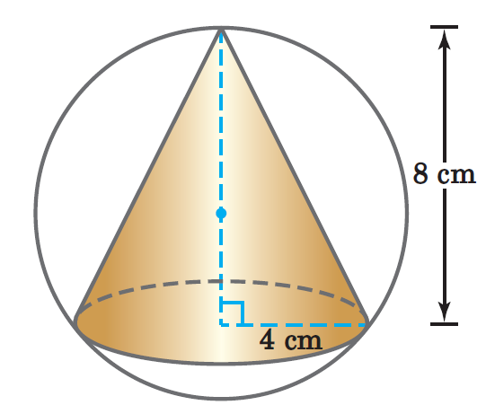

23. In the figure, a solid composed of a right cylinder and a hemisphere with the same base radius r is put into a cylindrical tank. The water is added to the tank such that it just covers the top of the solid. It is given that the base radius of the cylindrical tank is 2r.

The solid is then taken out from the tank and the water level drops by 20%.
(a) Express the height of the right cylinder in terms of r.
(b) If the total surface area of the solid is 975π cm², express the volume of water in the tank in terms of π.

